Certification Process and Procedure for issue of certificate, suspension, reduction and withdrawal

Certification Process

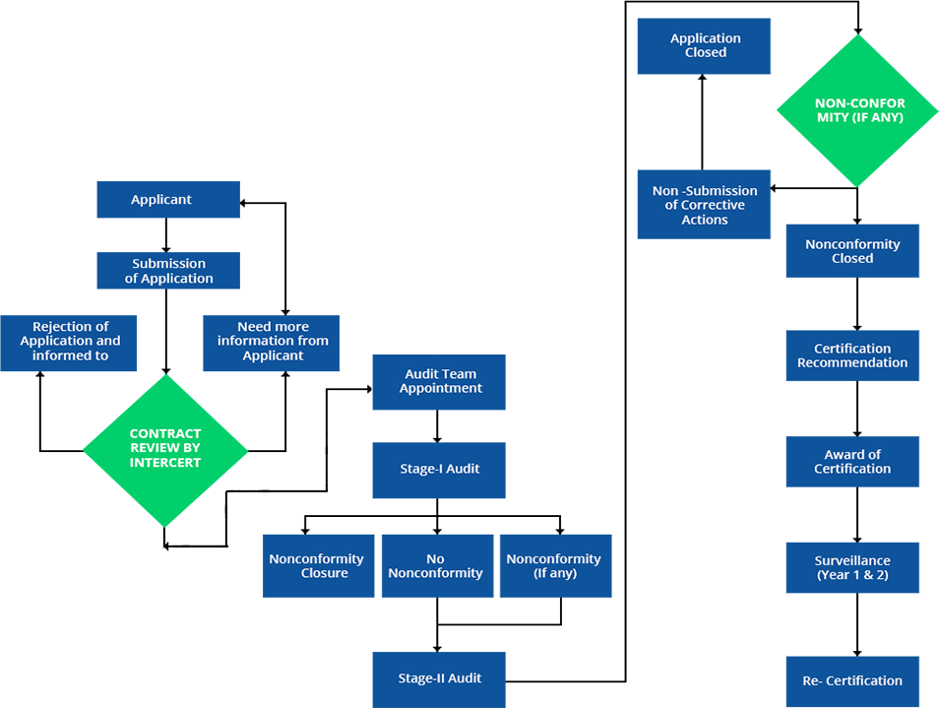

Procedure for issue of certificate, suspension, reduction and withdrawal

